Ecosystems:
- (Concepts, structure and function of an ecosystem),
- types,
- Functional components,
- biodiversity.

Concept of ecosystem
Life on our planet exists within the biosphere, where species interact with both living (biotic) and non-living (abiotic) components. The study of these relationships is known as ecology, and the ecosystem is its structural and functional unit. The lifecycle of organisms within an ecosystem highlights their interdependence with each other and the environment. Materials are continuously exchanged between living and non-living components of an ecosystem.
The biosphere is the part of the Earth where ecosystems operate, where the atmosphere, hydrosphere, and lithosphere come together to support life. Some ecological groupings, called biomes, are characterized by plants and animals of a specific regional climate and soil type. Each biome has a dominant vegetation, such as grasses or conifers, that is uniform throughout, although the specific plant species may vary. The physical environment and dominant vegetation of a biome determine the kind of animals that live there.
Structure and Function of an Ecosystem
The ecosystem is the functional unit of the environment and it consists of two main components - biotic and abiotic. Biotic components are living things such as plants, animals, and microbes, while abiotic components are non-living things like air, water, and minerals. Ecosystems can range in size from small microecosystems like a drop of pond water to large macroecosystems like an ocean.
Ecosystems can be generated naturally, such as a lake, or they can be created by humans, such as an aquarium. They may also be either permanent or temporary in nature.
The living components of an ecosystem make up the biotic component, which includes plants, animals, humans, and microbes. A closer examination of the biotic component shows that living organisms can be divided into two categories based on their ability to produce their own food. Autotrophs, or producers, are organisms that can make their own food through photosynthesis or chemosynthesis. Heterotrophs, or consumers, are organisms that must consume other organisms for energy.
You can see the biotic component illustrated in the accompanying figure.
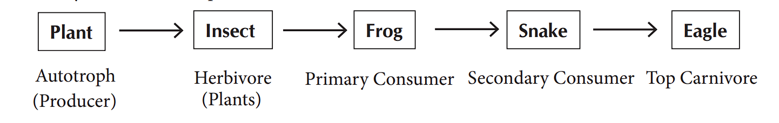

Autotrophic organisms, also known as producers, are living things that have the ability to produce their own food. This category includes green plants, algae, and certain bacteria that contain chlorophyll, which allows them to convert solar energy into chemical energy. These organisms can store food in the form of carbohydrates by using carbon dioxide and water in the process of photosynthesis.
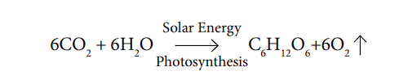
Because autotrophic organisms are capable of producing their own food, they are also referred to as self-feeders. They are the foundation of most food chains and play a critical role in maintaining the balance of ecosystems.

Heterotrophic components, also known as consumers, depend on autotrophs to obtain energy for survival. They include primary, secondary, and tertiary consumers, depending on their feeding habits. Primary consumers, or herbivores, eat autotrophs, while secondary consumers, or carnivores, eat herbivores. Tertiary consumers eat the flesh of secondary consumers and are known as top carnivores. Examples of these consumers include cows, horses, rabbits, insects, grasshoppers, frogs, lizards, tigers, lions, and vultures.

Saprophytes or Decomposers. In an ecosystem, the dead bodies of plants and animals are broken down by certain microbes such as bacteria and fungi. These decomposers break down the dead matter into simple substances, such as water, carbon dioxide, phosphates, nitrogen, sulphates, and organic compounds. This is a vital process, as it releases essential materials that can be used by producers, such as plants, to prepare food.
Without decomposers, these materials would be trapped in dead organic matter and not available for use by other living organisms. The decomposers play a crucial role in maintaining a continuous cycle of materials in the ecosystem. Some decomposers are also known as scavengers, as they feed on dead organisms.

Abiotic components are the non-living factors of an ecosystem that have a significant impact on the survival and growth of biotic components. Abiotic components include various physical and chemical factors such as light, temperature, water, air, soil, minerals, and nutrients. These factors affect the biotic components in different ways, and the interaction between biotic and abiotic components is critical to the survival of the ecosystem. For example, the amount of rainfall and the quality of soil are essential abiotic factors that affect the growth and survival of plants, which in turn affect the survival of animals that depend on those plants for food. In short, the abiotic components form the physical and chemical foundation of the ecosystem, which supports the biotic components.

Types of Ecosystem

An ecosystem can be categorized into four major types of habitats: marine, freshwater, terrestrial and man-engineered (agriculture).
Marine ecosystem includes all the saline water reservoirs on earth such as the seas, oceans and estuaries with their characteristic biome.
Freshwater ecosystem comprises of ponds, streams, rivers and lakes along with their flora and fauna.
Terrestrial ecosystem includes various types of ecosystems such as desert ecosystem, grassland ecosystem, tree ecosystem, crop fields, forest ecosystem, etc.
Man-engineered ecosystem refers to agriculture and aquaculture systems which are created by humans. These ecosystems have all the essential components such as producers, consumers (both herbivores and carnivores), decomposers and abiotic materials. However, they are fragile and highly productive and generate lots of pollutants compared to natural ecosystems which are more stable and polyculture systems.
In summary, ecosystems can be natural or man-made, permanent or temporary, and consist of both living (biotic) and non-living (abiotic) components.
Biodiversity

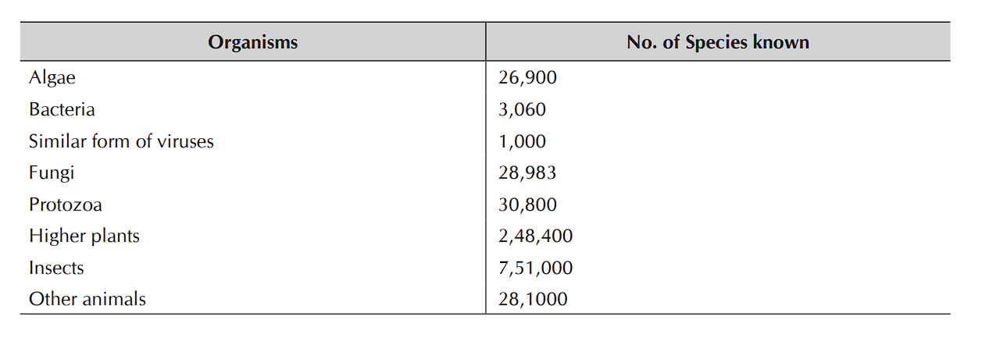
The diversity of organisms in an ecosystem is a very important feature. The diversity of species is the least at the poles and increases progressively towards the tropics. Diversity decreases due to stress, both natural and man-made. The greater the diversity, the better is the ecosystem. There are about 2, 89,100 species of plants and fungi and 10, 53,800 species of animals presently known to scientists. The following table gives an idea of the different types of living species in the biosphere which is an indicator of biodiversity

Biodiversity in its broadest sense includes the following diversities:

Taxonomical: The existence of a variety of species, ecological, inter- and intra-specific relationships and niches of ecosystems;

Adaptational: Species adapting to the environmental changes for survival, reproduction and continence;

Genetic: Intra- and inter-specific genetic variations between the species that makes a differentiation between them and

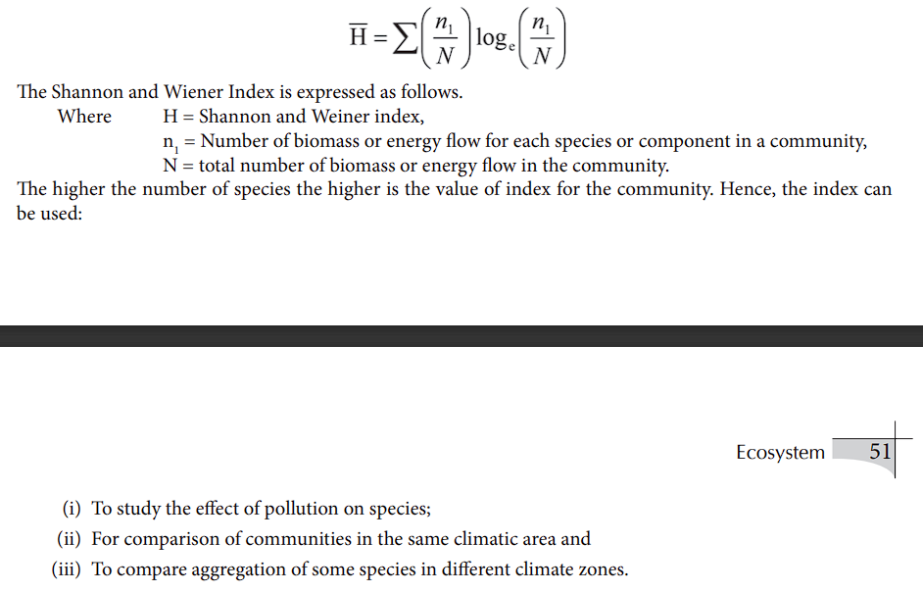
Biochemical: Metabolic and chemical diversities synthesized by organisms. Countries where there is an abundant diversity of plants and animals are called megadiversity countries. Brazil tops the list of being a megadiversity country with the highest number of flowering plant species. India with the prevalence of a wide range of soils, habitats and climatic conditions is also a country of megadiversity. However, the rate of deforestation in India (2.7 per cent), which is the highest rate among the megadiversity countries poses a great threat to the country’s rich biodiversity. The number of species in a community or its ‘specie richness’ by itself, is an inadequate indicator of the diversity of species. The relative abundance of each species is also important. Hence, ecologists consider both the richness and relative abundance of the species to measure its diversity. When an ecosystem is adversely affected by man-made or natural causes, some sensitive species might get eliminated. In other words, the richness of the species decreases but this decrease may favour the relative abundance of some others. For example,water hyacinths growabundantly in a polluted pond at the cost ofsome sensitive species of organisms and fishes. Ecologists express diversity in species by two common indices namely The Simpson Index and the Shannon–Wiener Index

